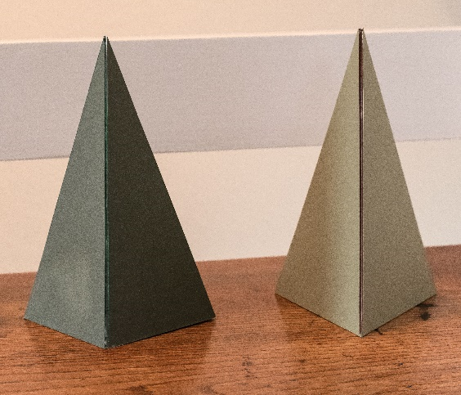
MY CHRISTMAS TREES by Colin & Sue Balch

The basic shape is made from card triangles (either 3 or 4 sides) held together with sticky tape. See the attached photo. They are approx. 10” high.

The coverings are:-

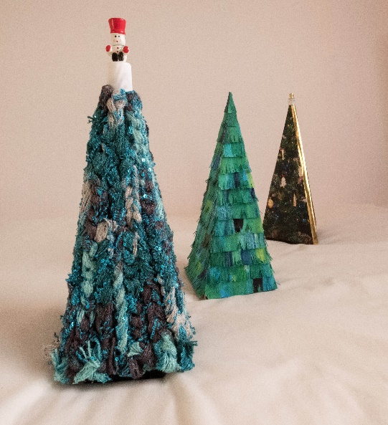
- Photographs of last year’s Christmas tree printed 3 times and stuck onto the card. Gold foil covers the edges.
- I painted an A3 sheet of cartridge paper with green, blue, yellow & black acrylic paints quite at random. After it dried, I cut it at right angles into strips about 1” wide, then used a scissors to cut a half depth fringe. The strips were then cut to fit, & glued on, from the bottom up, over-lapping half depth. The fringe was then teased up to look like small branches.
- Sue had some acrylic wool of the right colours, which she plaited. It was then stuck onto the card backing & trimmed. It was a bit ragged at the top, so we put a cap with the toy soldier to keep it all tidy.

Colin and Sue Balch
